Air quality analysis

Introduction
Air quality is typically assessed using monitoring stations, sensors, and satellite data. The data collected is used to calculate Air Quality Index (AQI) values, which provide an indication of the overall air quality and its potential health impacts. Air quality analysis is essential for public health, environmental protection, and urban planning.
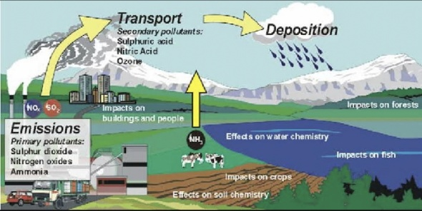

DATA SOURCE

From smog hanging over cities to smoke inside the home, air pollution poses a major threat to health across the globe. Almost all of the global population (99%) are exposed to air pollution levels that put them at increased risk for diseases including heart disease, stroke, chronic obstructive pulmonary disease, cancer and pneumonia. WHO monitors the exposure levels and health impacts (i.e. deaths, DALYs) of air pollution at the national, regional and global level from ambient (outdoor) and household air pollution. Such estimates are used for official reporting like the world health statistics, and the Sustainable Development Goals.

Air Pollution Data Portal

Burden of disease

6.7 million

Deaths each year from exposure to ambient and household air pollution

Household exposure

2.3 billion

People primarily rely on polluting fuels and technologies for cooking in 2021

Ambient exposure

99%

Of the world’s population live in places where air pollution levels exceed WHO guideline limits

AIR QUALITY CONSIDERATION
Considering air quality is important for your health and well-being. Factors like pollution, allergens, and indoor air quality can impact your respiratory health. Be mindful of outdoor air quality alerts and maintain good ventilation indoors to ensure a healthier living environment.
STEPS IN AIR QUALITY ANALYSIS:
Analyzing air quality typically involves the following steps:

Data Collection: Gather air quality data from monitoring stations, sensors, or sampling equipment. This data may include information on pollutants like particulate matter (PM2.5, PM10), volatile organic compounds (VOCs), nitrogen dioxide (NO2), ozone (O3), carbon monoxide (CO), and sulfur dioxide (SO2).

Data Validation: Ensure the collected data is accurate and reliable by checking for inconsistencies or errors.
Data Analysis: Use statistical and analytical techniques to process and interpret the data. Identify trends, patterns, and potential sources of pollution.

Regulatory Compliance: Assess air quality against established regulatory standards and guidelines to determine if pollution levels are within acceptable limits.

Modeling: Employ computer models to simulate air dispersion and predict pollutant concentrations under different conditions. This helps in understanding the spatial distribution of Pollutants.
Mitigation Strategies: Develop and recommend strategies to reduce air pollution, which may include regulatory measures, emissions controls, and public awareness campaigns.

Reporting and Communication: Share findings and recommendations with relevant authorities, the public, and stakeholders to foster transparency and informed decision-making.

Continuous Monitoring: Implement a system for ongoing air quality monitoring and analysis to track changes over time and assess the effectiveness of pollution control measures.
3.SOLUTION FOR AIR QUALITY ANALYSIS:
Air quality analysis is the process of assessing and monitoring the composition of the air in a specific area to determine its quality. This typically involves measuring various pollutants and particles in the air, such as:

Particulate Matter (PM): These are tiny particles in the air that can have adverse health effects when inhaled. PM2.5 and PM10 are commonly measured.

Ground-level Ozone (O3): Ozone near the Earth’s surface is a key component of smog and can be harmful to human health.
Nitrogen Dioxide (NO2) and Sulfur Dioxide (SO2): Gases produced by combustion processes that can lead to respiratory problems and air pollution.

Carbon Monoxide (CO): A colorless, odorless gas that can be harmful when inhaled in large quantities.

Volatile Organic Compounds (VOCs): Organic chemicals that can contribute to air pollution.

Air quality is typically assessed using monitoring stations, sensors, and satellite data. The data collected is used to calculate Air Quality Index (AQI) values, which provide an indication of the overall air quality and its potential health impacts. Air quality analysis is essential for public health, environmental protection, and urban planning.
Conclusion:
In conclusion, air quality analysis is a crucial tool for understanding and managing the quality of the air we breathe. Through the measurement of pollutants and particles, the assessment of air quality, and the calculation of Air Quality Index (AQI) values, we can gain insights into the health of the environment and its potential impacts on human health. This information is vital for making informed decisions related to public health, environmental protection, and urban development. It underscores the importance of continued monitoring and efforts to improve air quality to ensure a healthier and more sustainable future.

